Honda WRV 1.2 VX (i-VTEC)- 2017 - 36 000 kms- price 5,50,000Rs - Diplomatic numbers (CD) but can be purchased by anyone paying required taxes

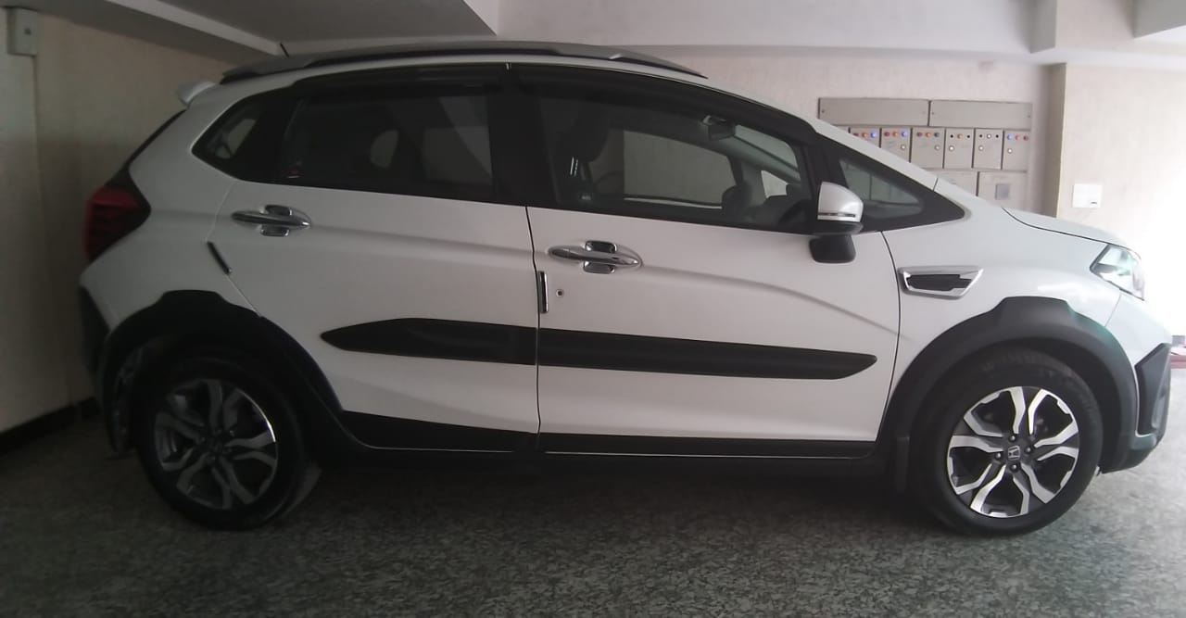

Sofa 3-2-1 : Price 1,20,000 Rs
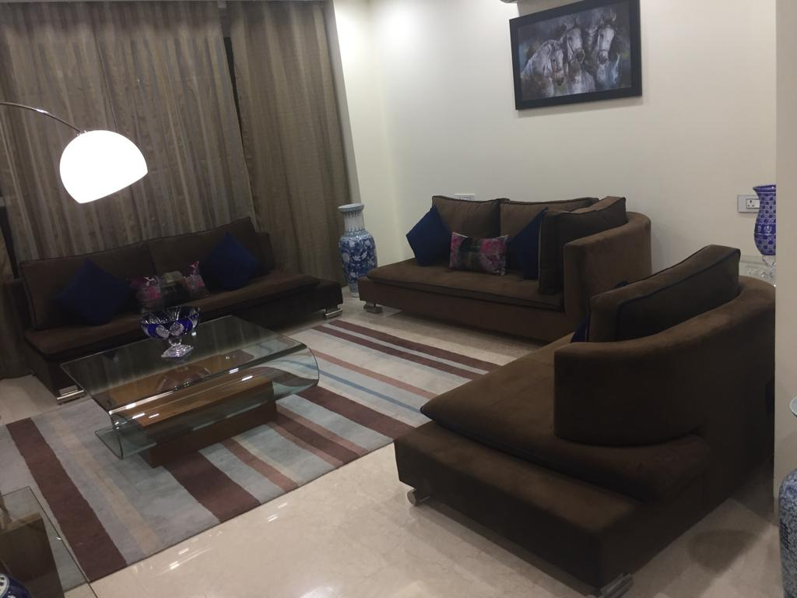

Dining table + 6 chairs : Price 25,000Rs
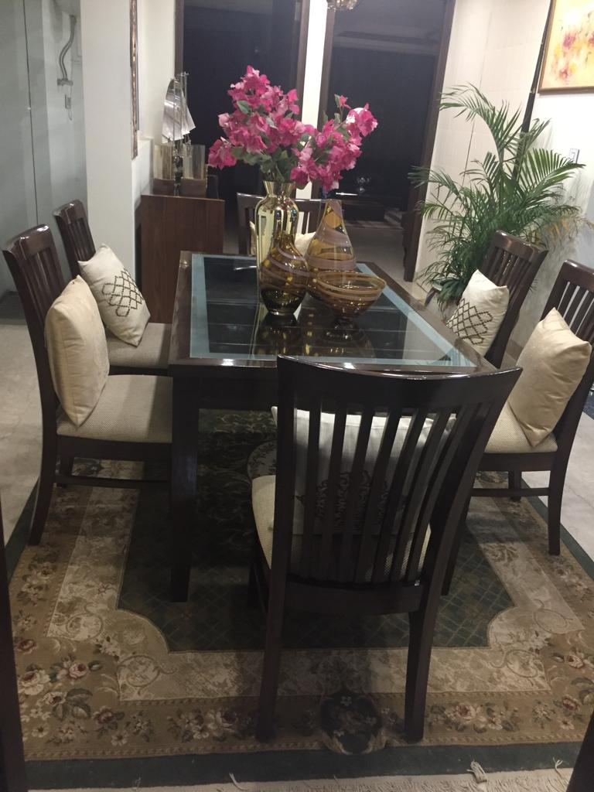

Black leather sofa 3-1-1-1 : price 1,50,000 Rs
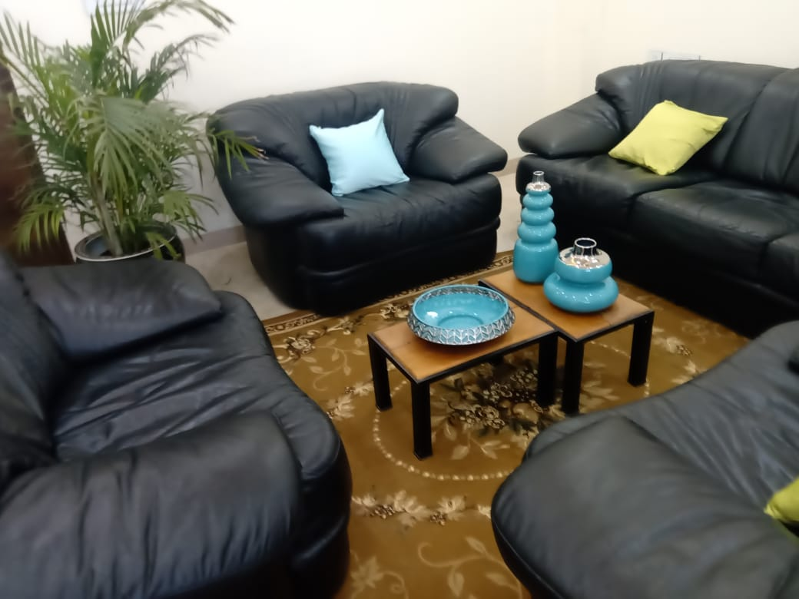

King size bed + mattress: price 20,000 Rs

